# INTRODUCTION

Analyzing the Performance & Efficiency of The Radisson Hotels Using Data Visualization Techniques

# 1.1 OVERVIEW

**Project Description**

The hotel industry is a broad category of business that provide lodging services for travelers and tourists. This can include a wide range of establishments, from luxury resorts to budget-friendly motels, as well as extended stay hotels, boutique hotels, and more. Hotels can be found in nearly every corner of the world, and are often a major component of the tourism and travel industry in a given area.

* 1. **Purpose**

Radisson owns multiple five-star hotels across India. They have been in the hospitality industry for the past 100 years. Due to strategic moves from other competitors and ineffective decision-making in management, Radisson is losing its market share and revenue in the luxury/business hotels category. As a strategic move, the managing director of Radisson wanted to incorporate Business and Data Intelligence in order to regain their market share and revenue. Our task is to create an analytics dashboard & story to provide them insights to make better business decisions.

We have achieved that the following ideas from the data given.

* An occupancy split by city.
* An occupancy percentage.
* An occupancy by day type.
* The revenue split by city.
* Revenue by Room Class
* Booking percentage by platform
* Property by key metrices
* Revenue contribution percentage by category
* Successful bookings by city
* Successful bookings by Datewise
* Total Revenue for the hotels
* Total Successful bookings

1. **Problem Definition & Design Thinking**

2.1 Empathy Map

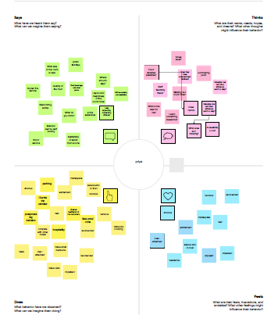

* 1. Ideation & Brainstorming Map

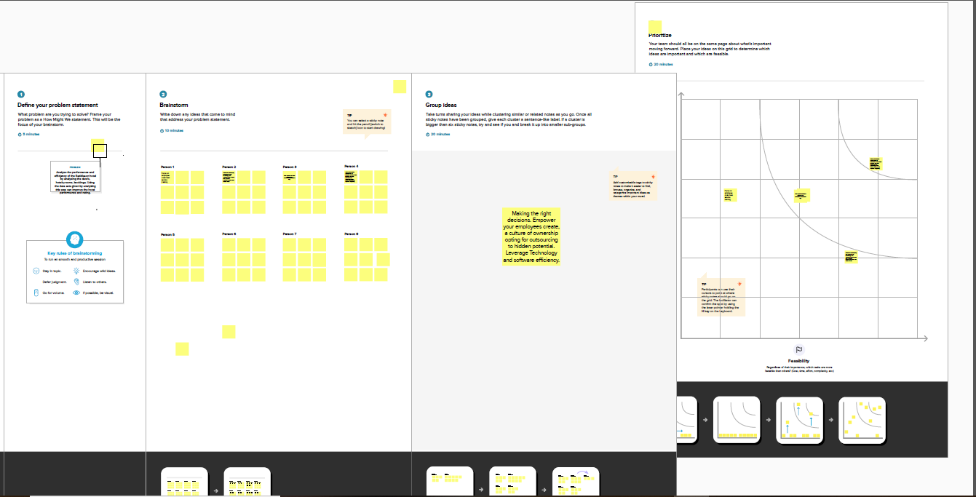

# 3. RESULTS

* Radisson Exotica has received highest revenue from Mumbai.

.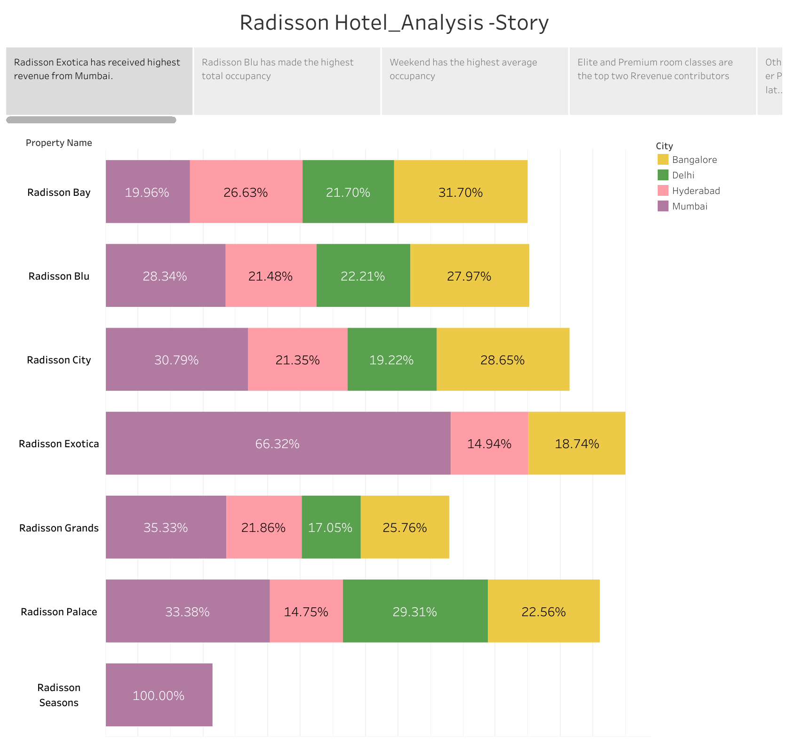

* Radisson Blu has made the highest total occupancy.

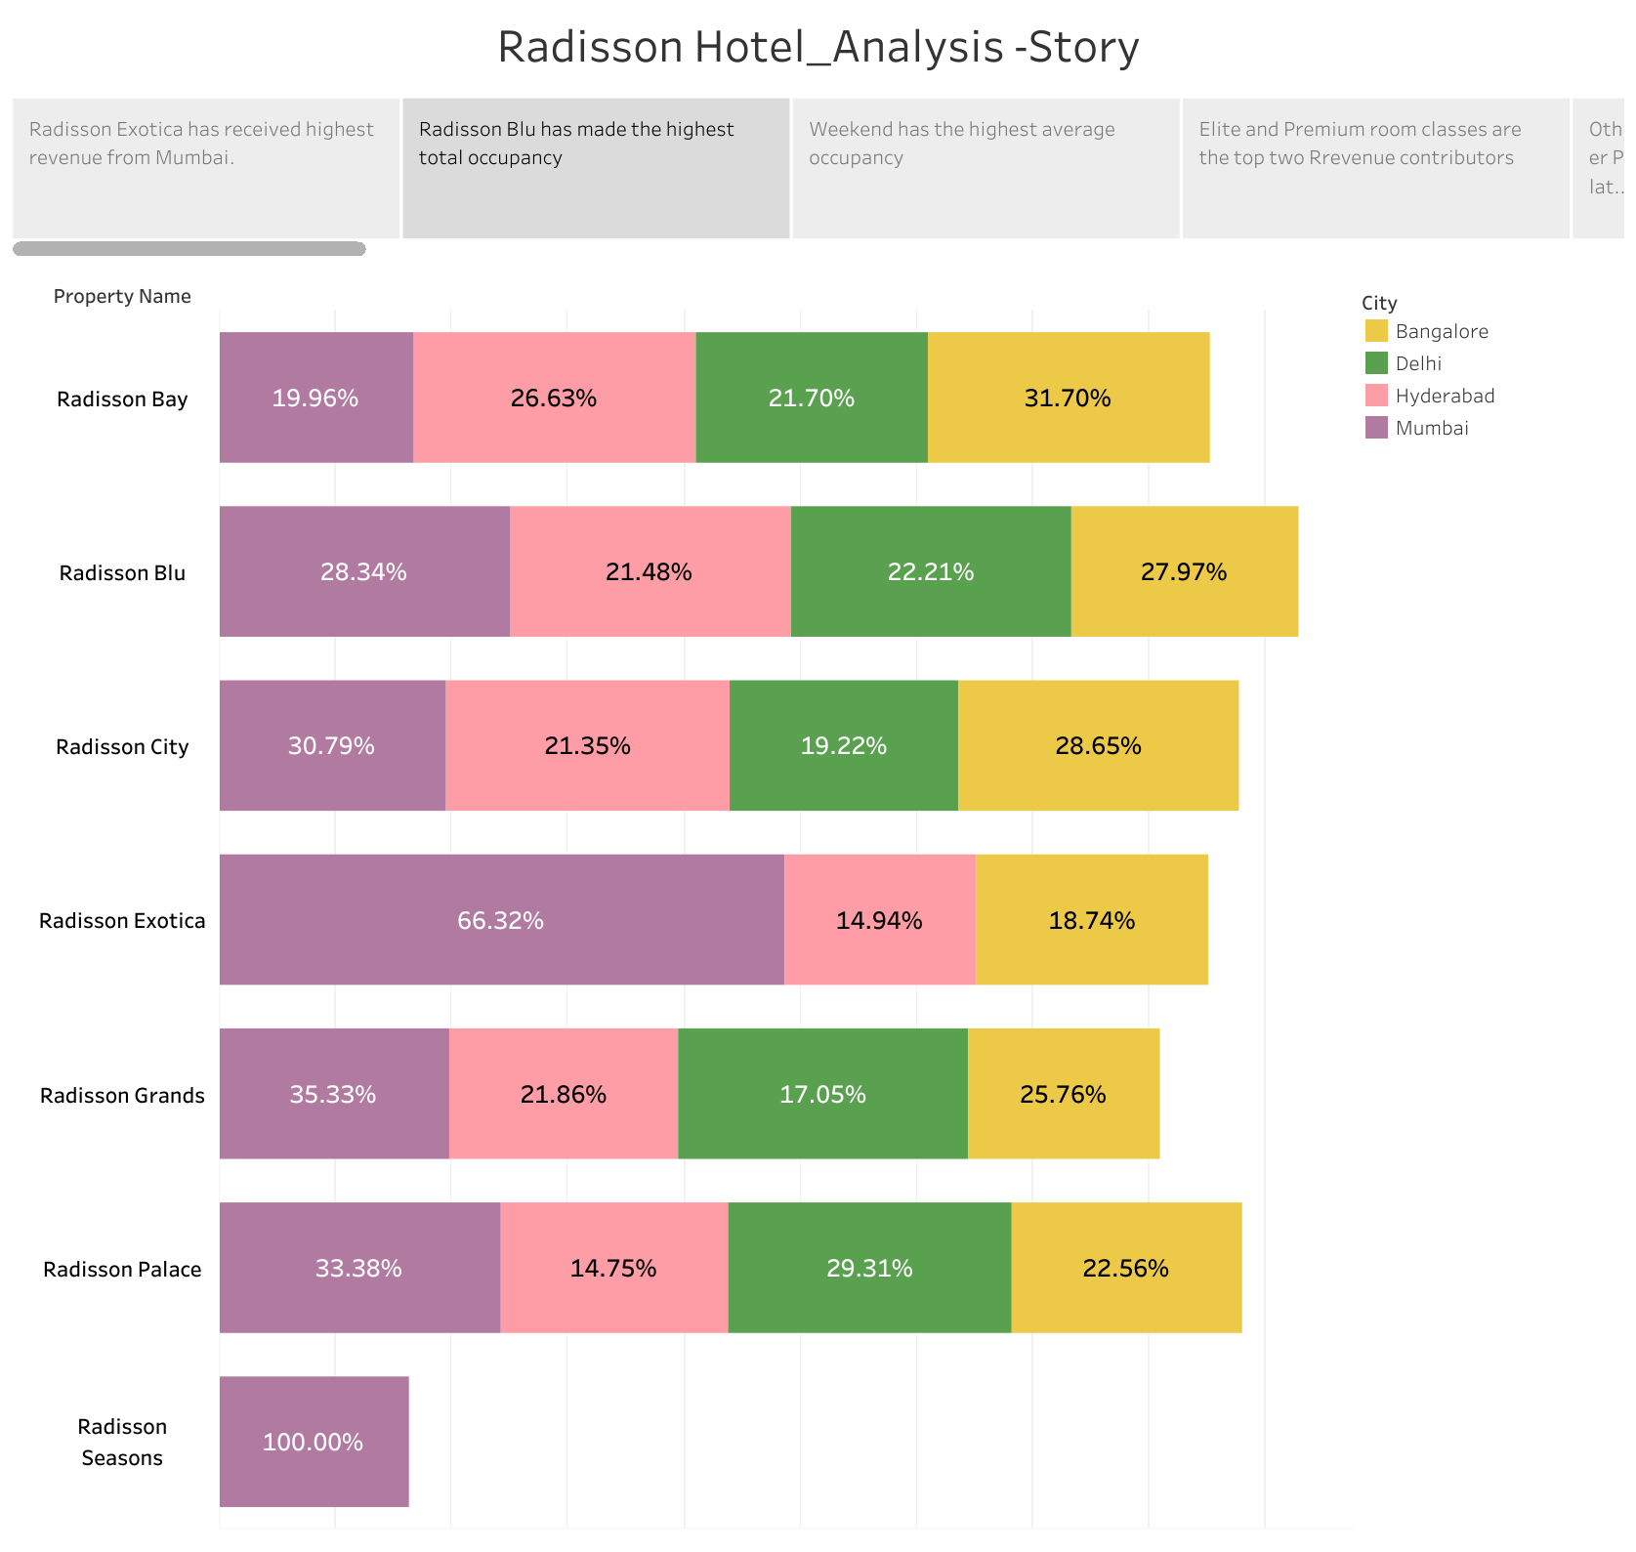

* Weekend has the highest average occupancy.

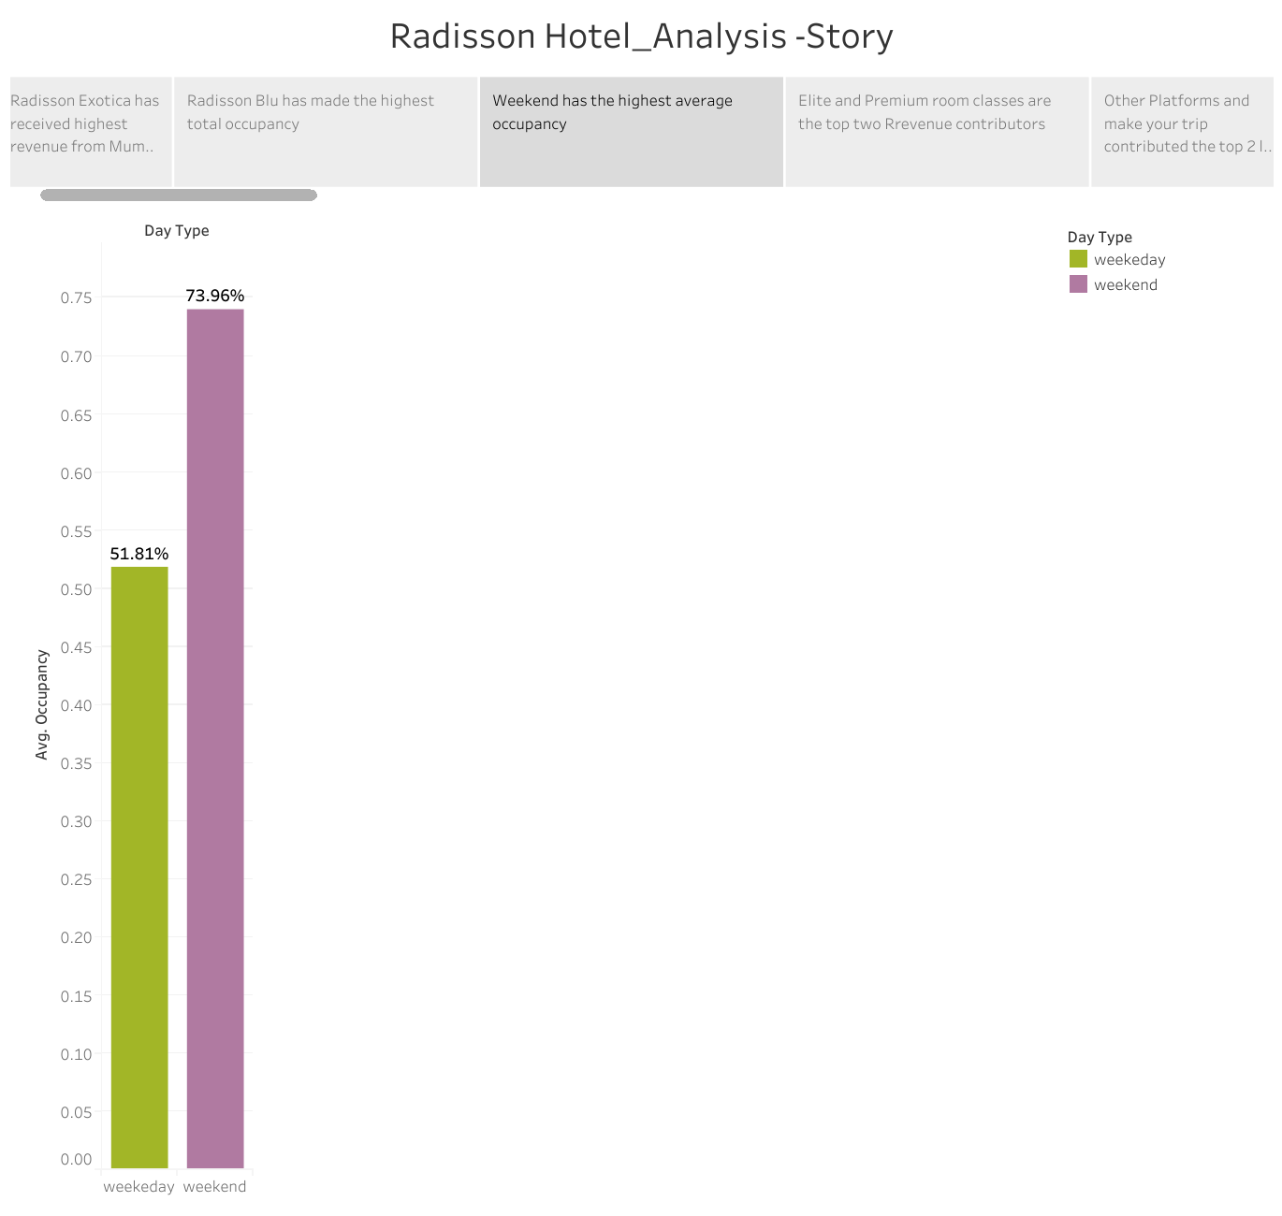

* Elite and premium room classes are the top do revenue contributors.

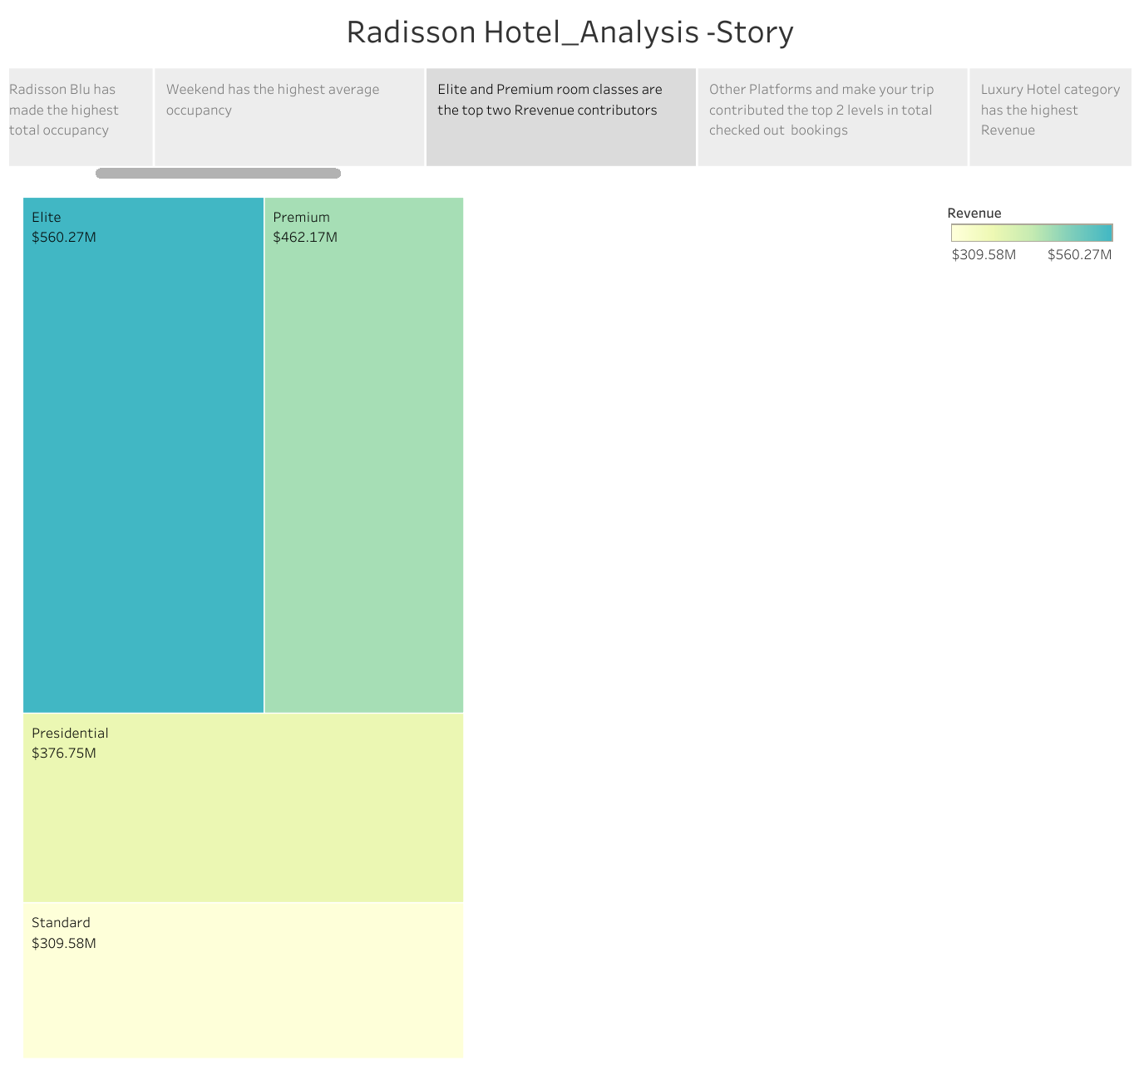

* Other platforms and make your trip contributors the top two level in total checked out bookings.

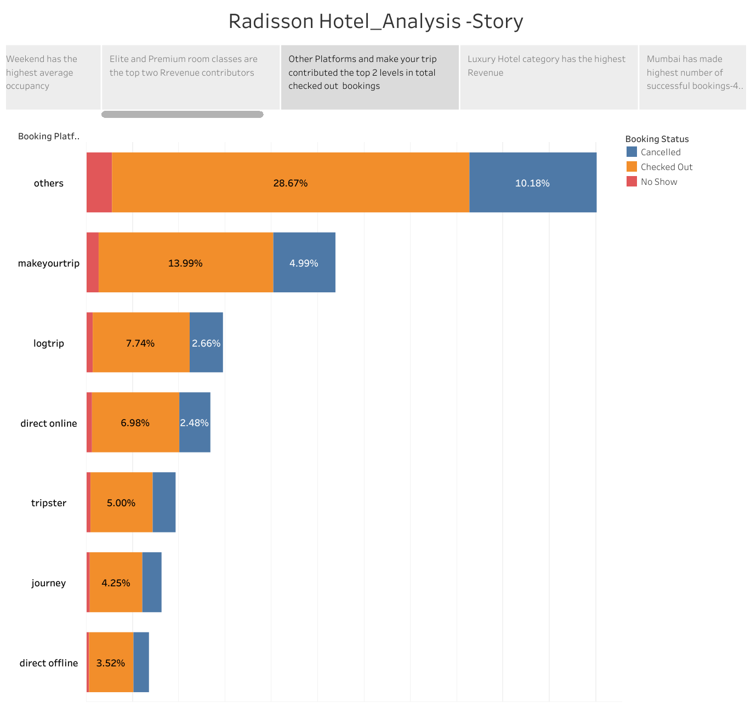

* Luxury hotels category has the highest revenue.

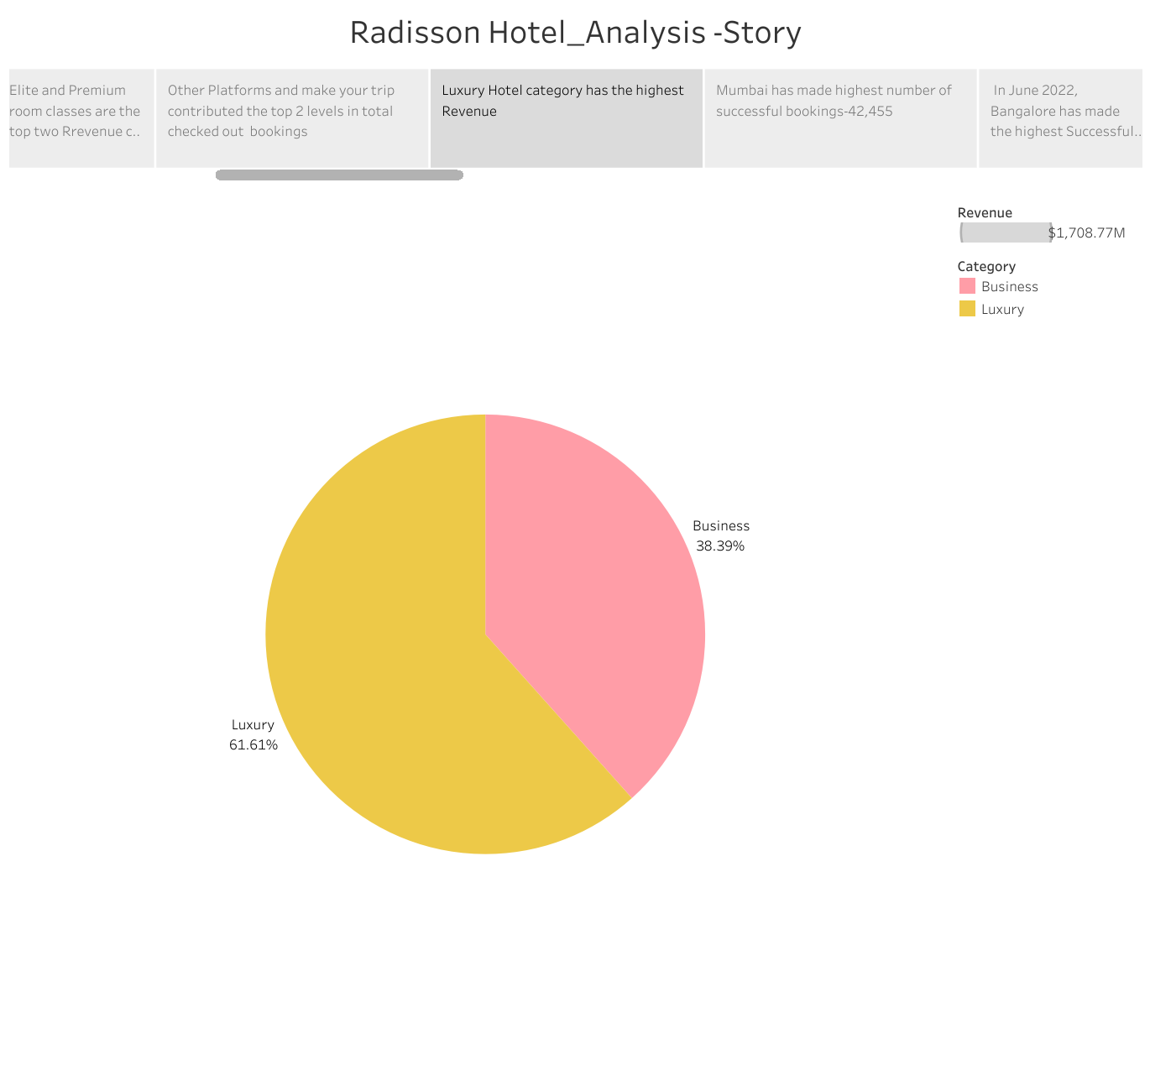

* Mumbai has made highest number if successful bookings 43,453.

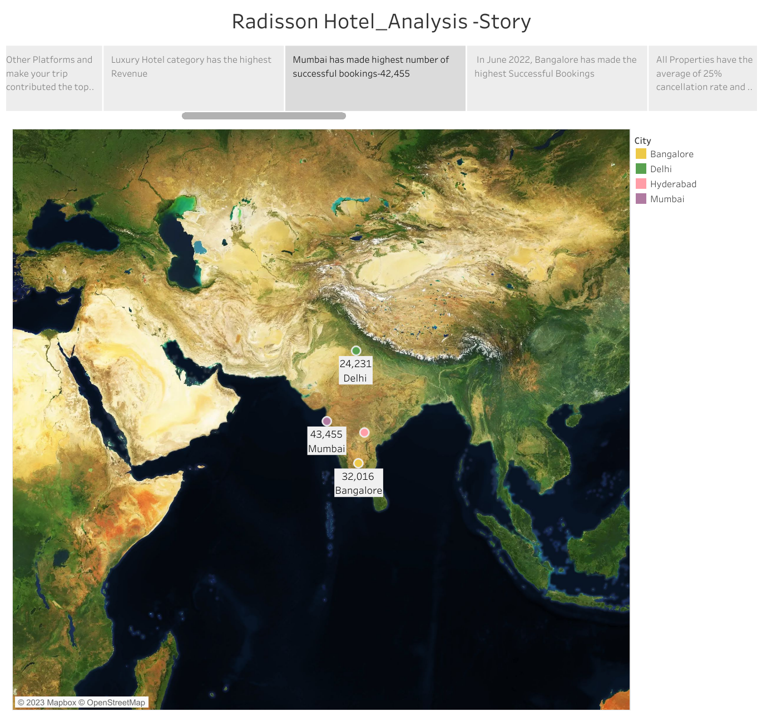

* In June 2022, Bangalore has made highest successful bookings.

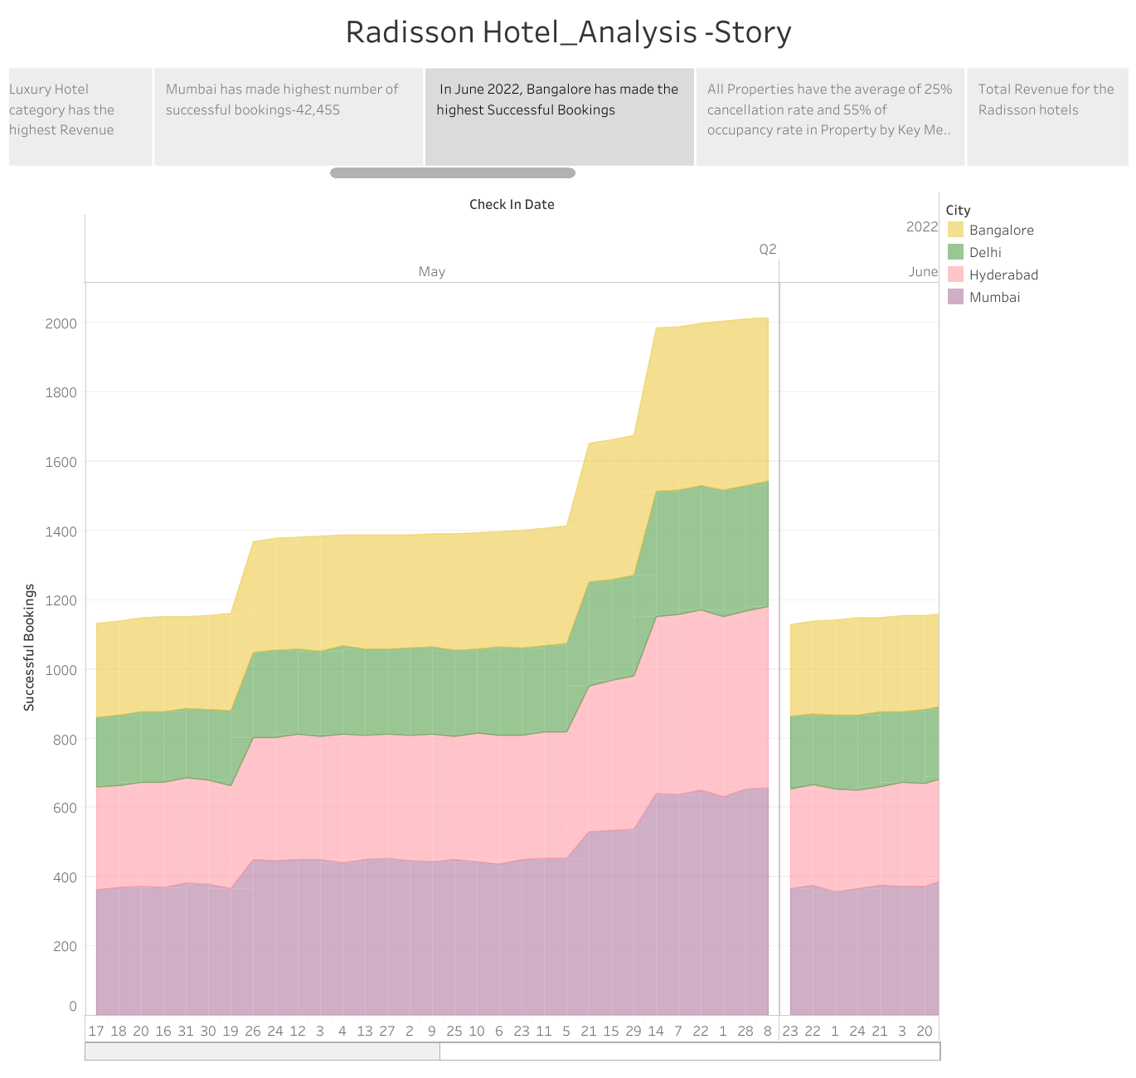

* All properties have the average of 25% cancellation rate and 55% of occupancy rite in property by key metrices.

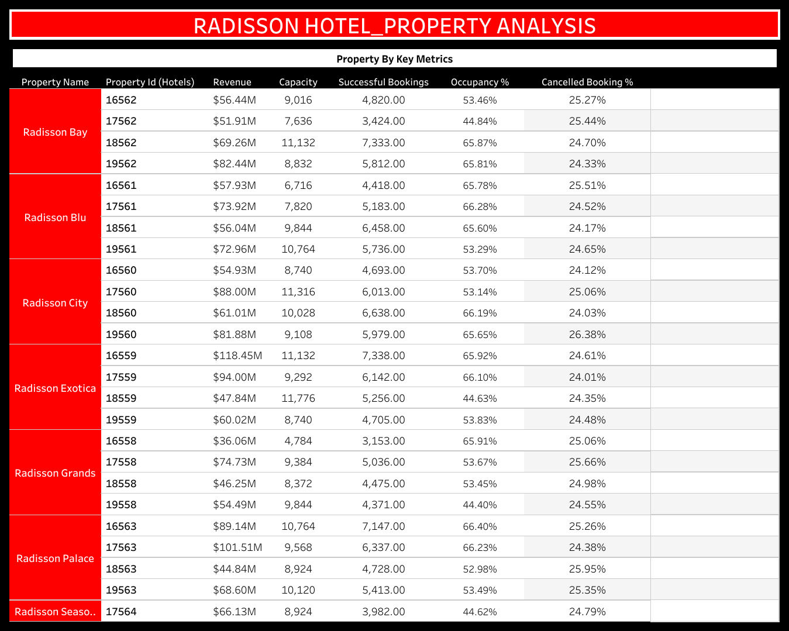

* Total revenue for the Radisson hotels .

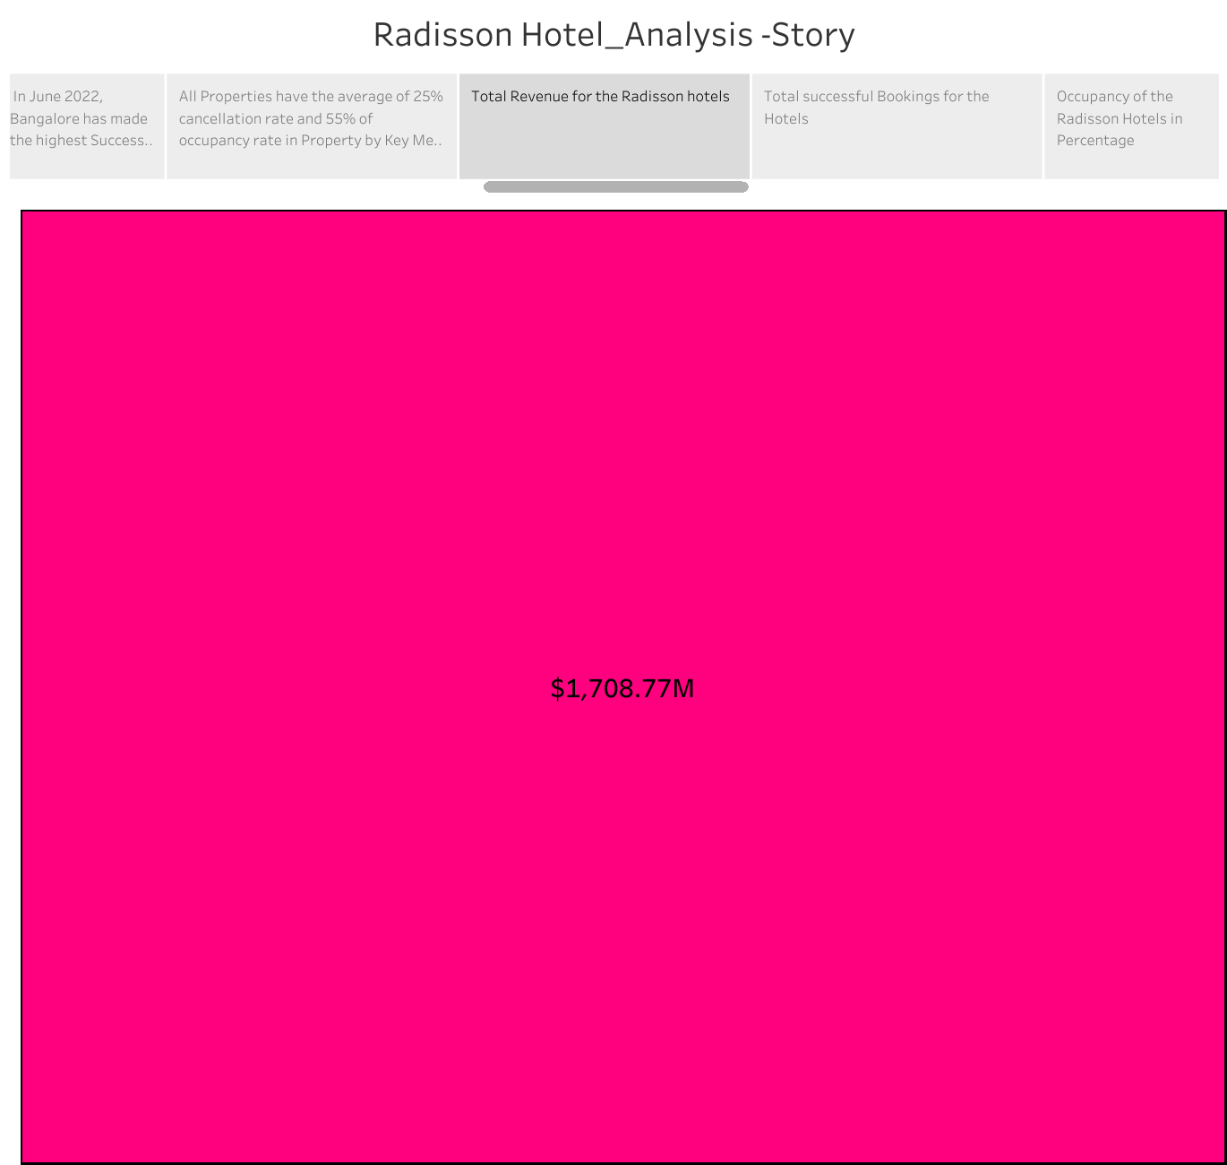

* Total successful bookings for the hotels.

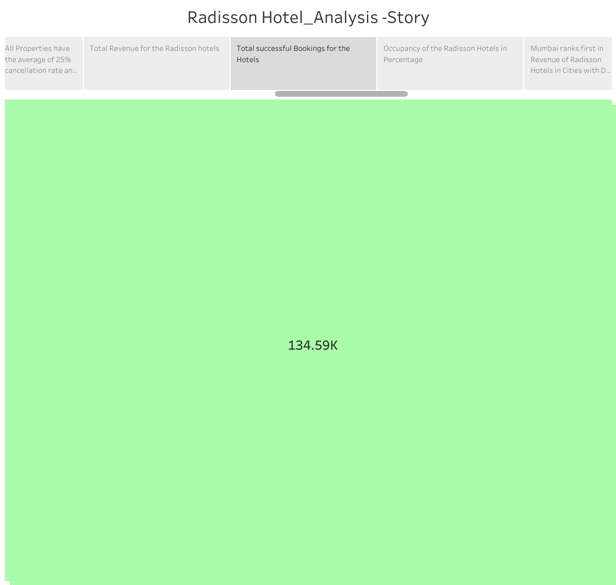

* Occupancy of the Radisson Hotels percentage.

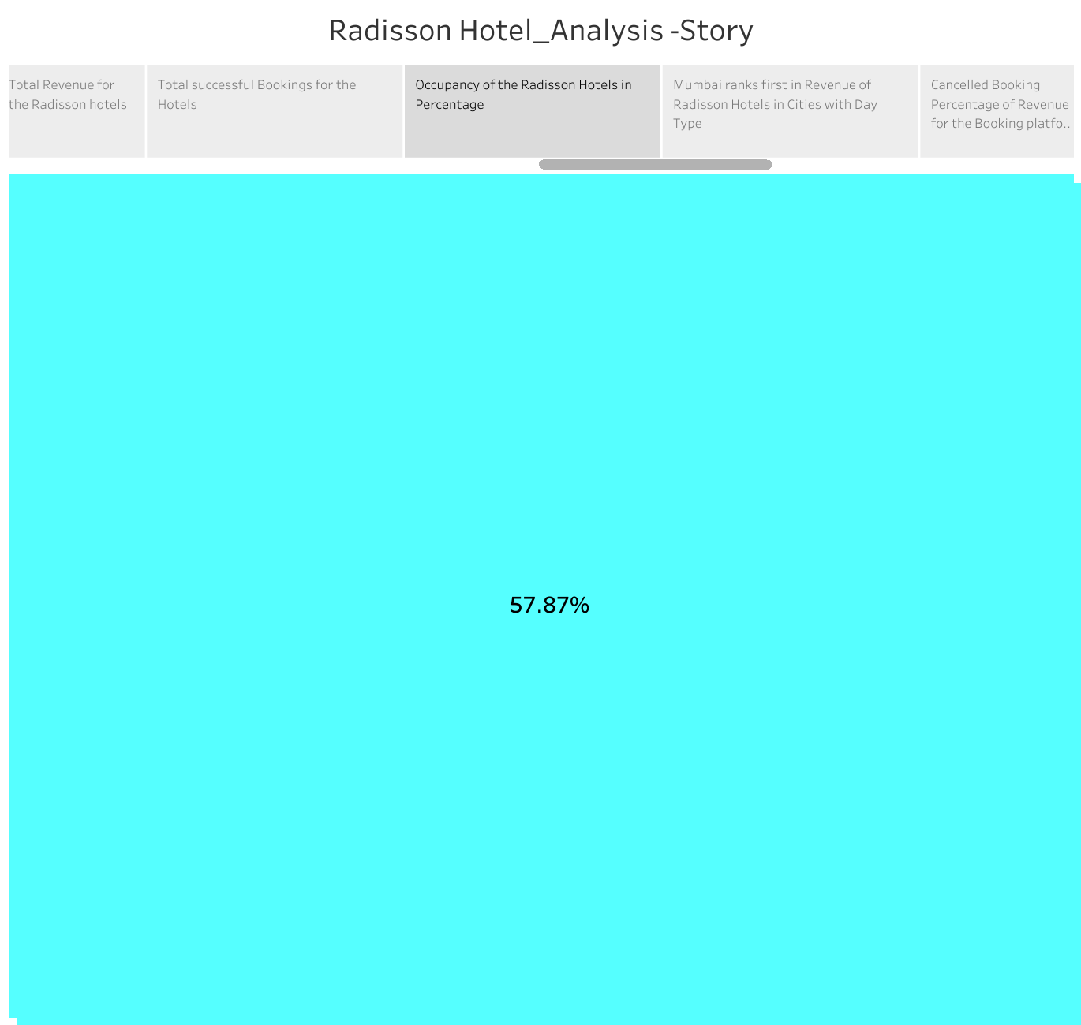

* Mumbai ranks first in revenue of Radisson Hotels in cities with day type .

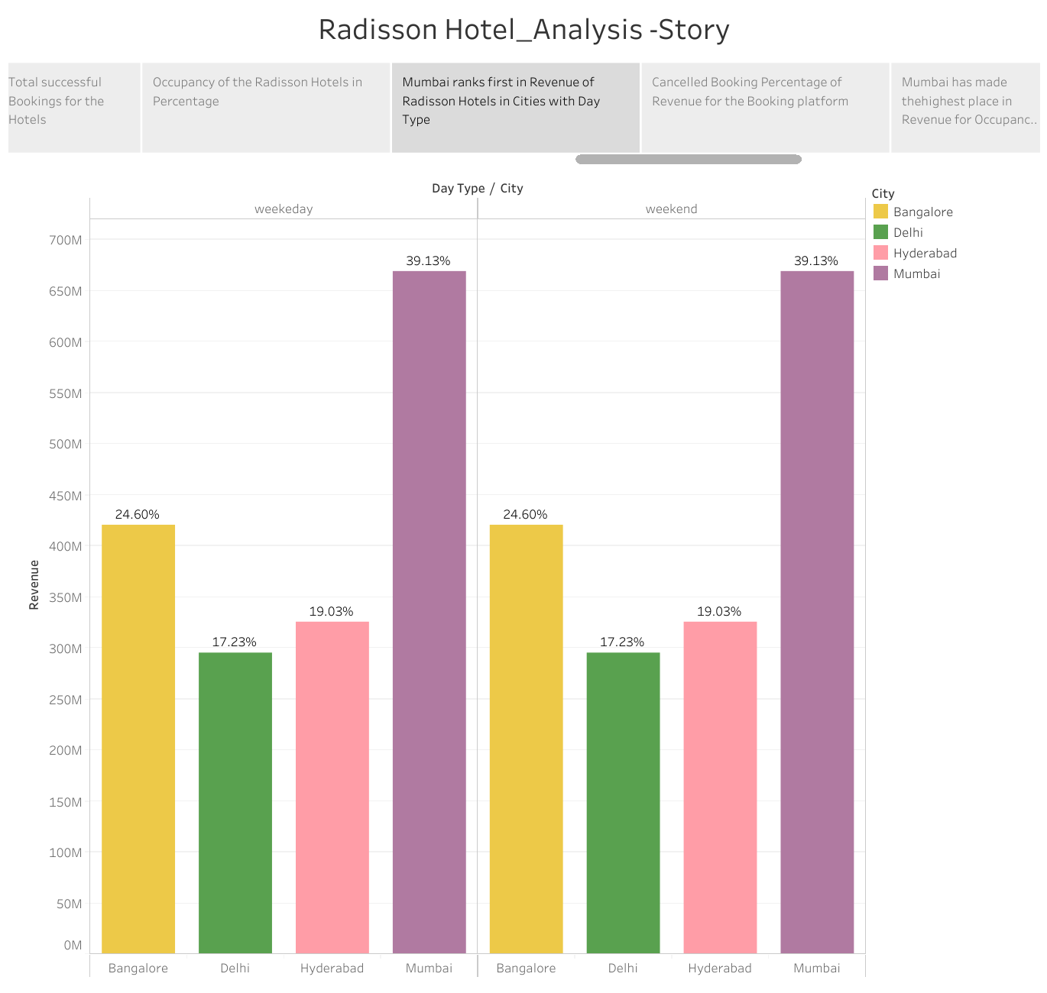

* Cancelled bookings percentage of Revenue for occupancy 96 of the hotels .

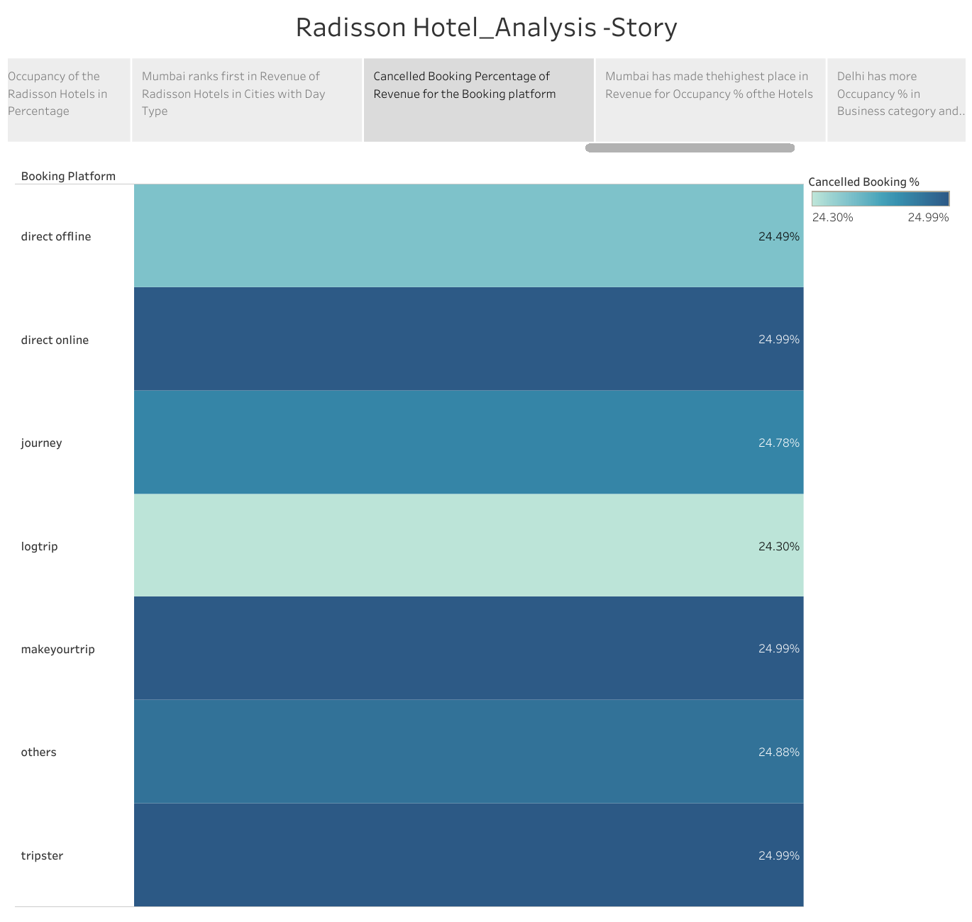

* Mumbai has made highest percentage in revenue Occupancy for the Radisson hotels.

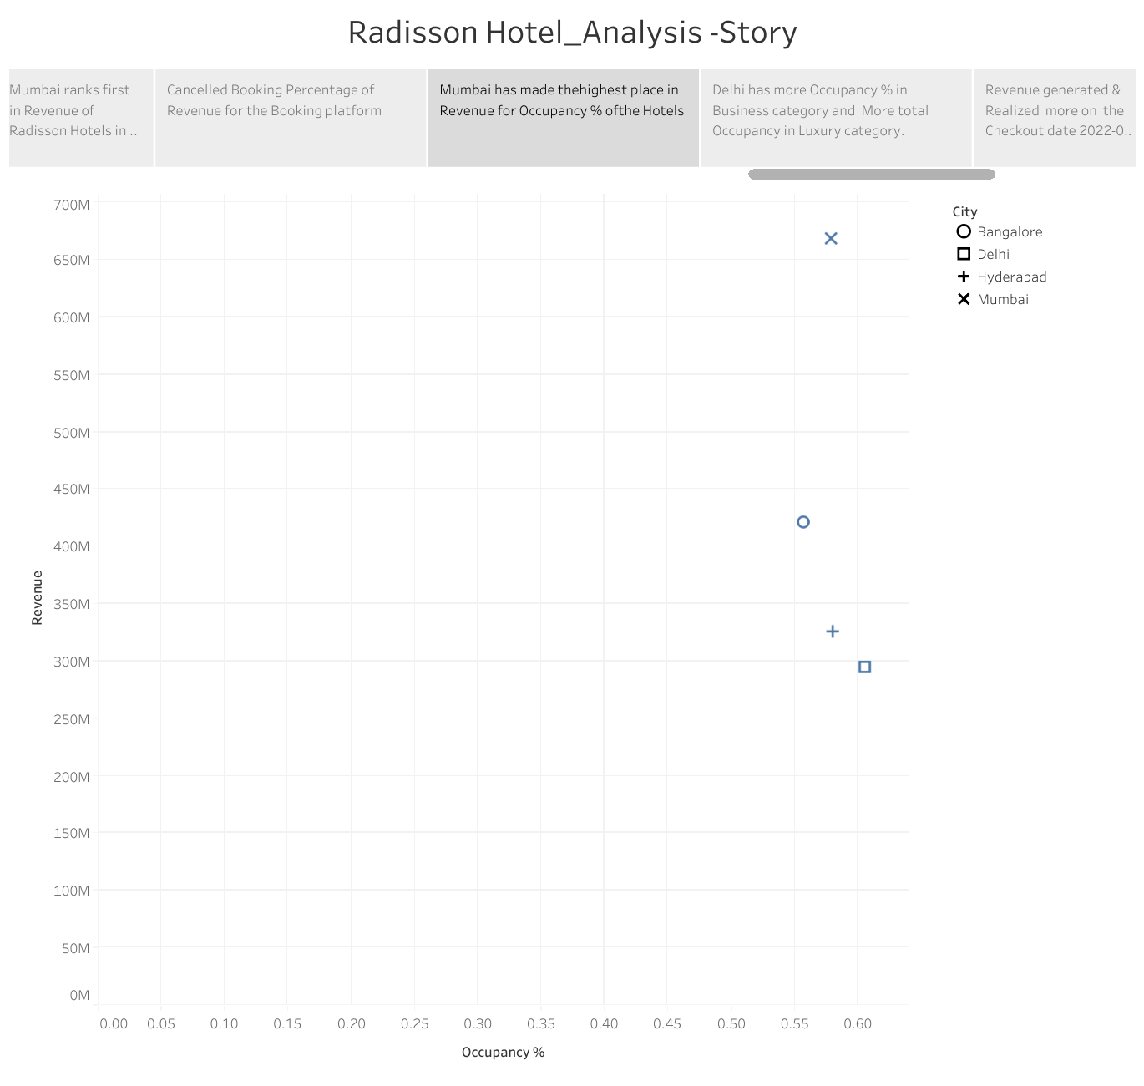

* Delhi has more occupancy 96 in Business category and more total occupancy in luxury category.

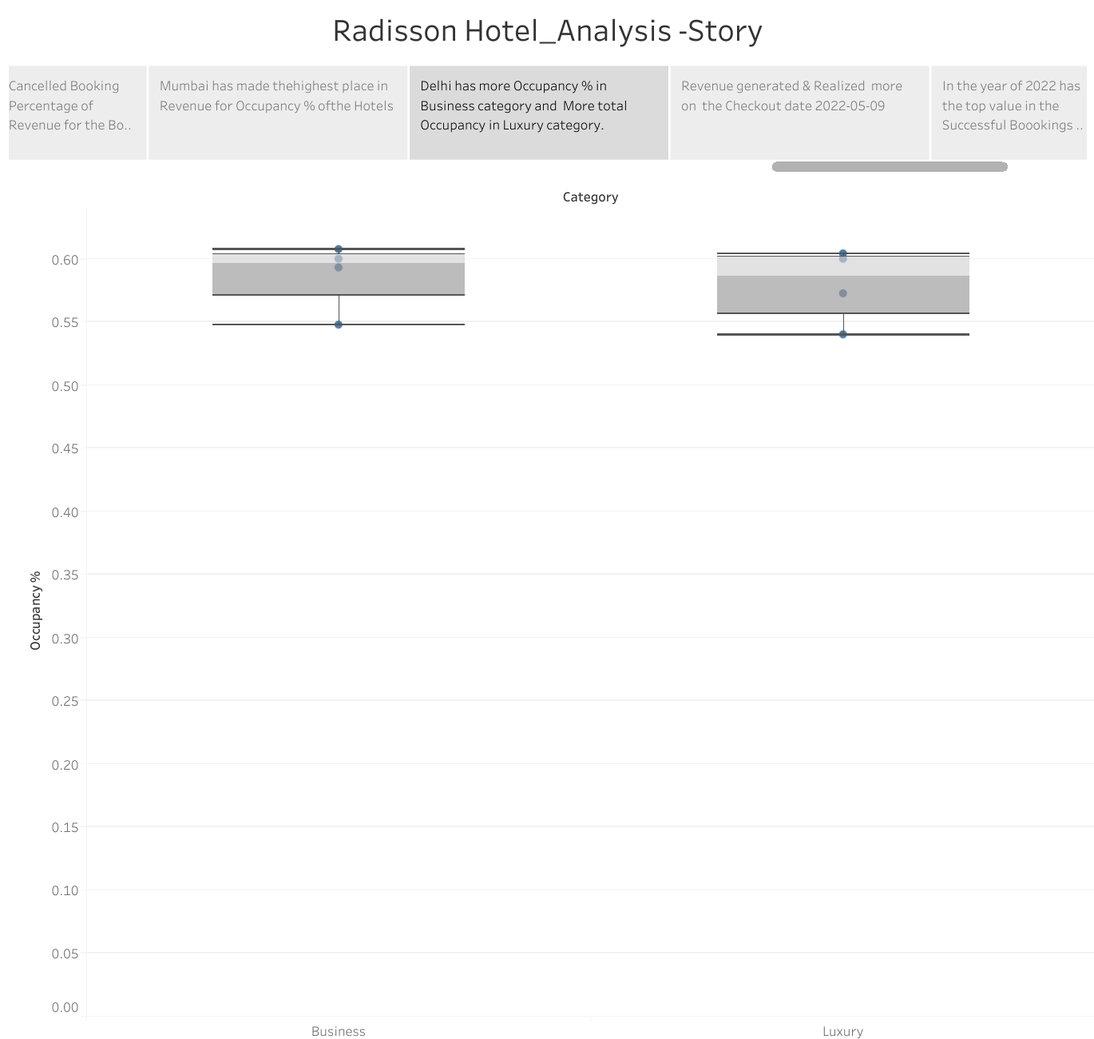

* Revenue generated and realized more on the checkout date 2022/05/09.

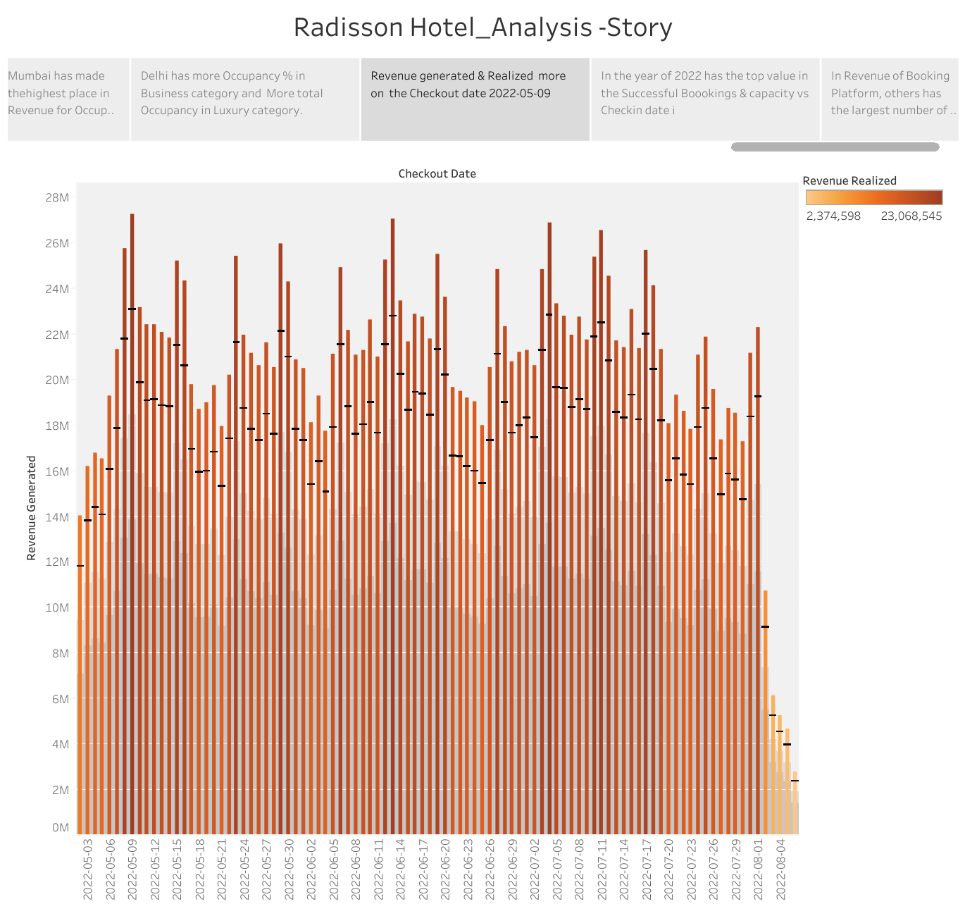

* In the year of 2022 has the top value in the successful bookings and capacity vs check in date.

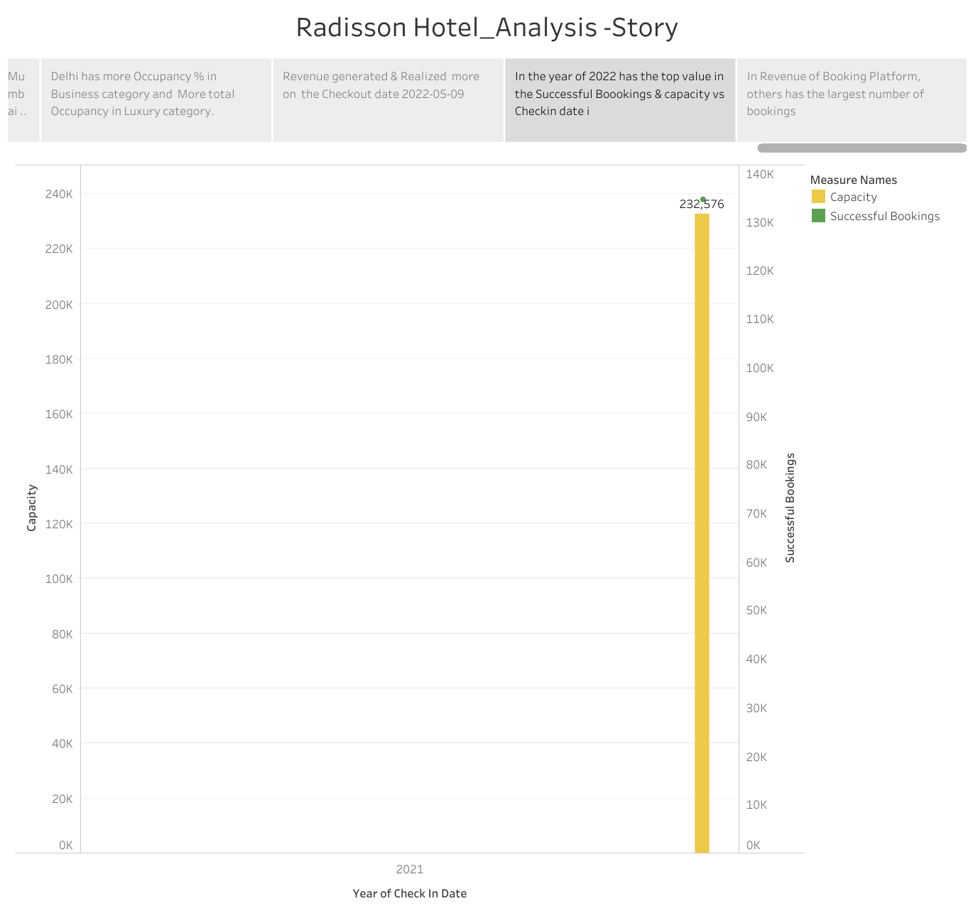

* In revenue of bookings platform, others has the largest number of bookings.

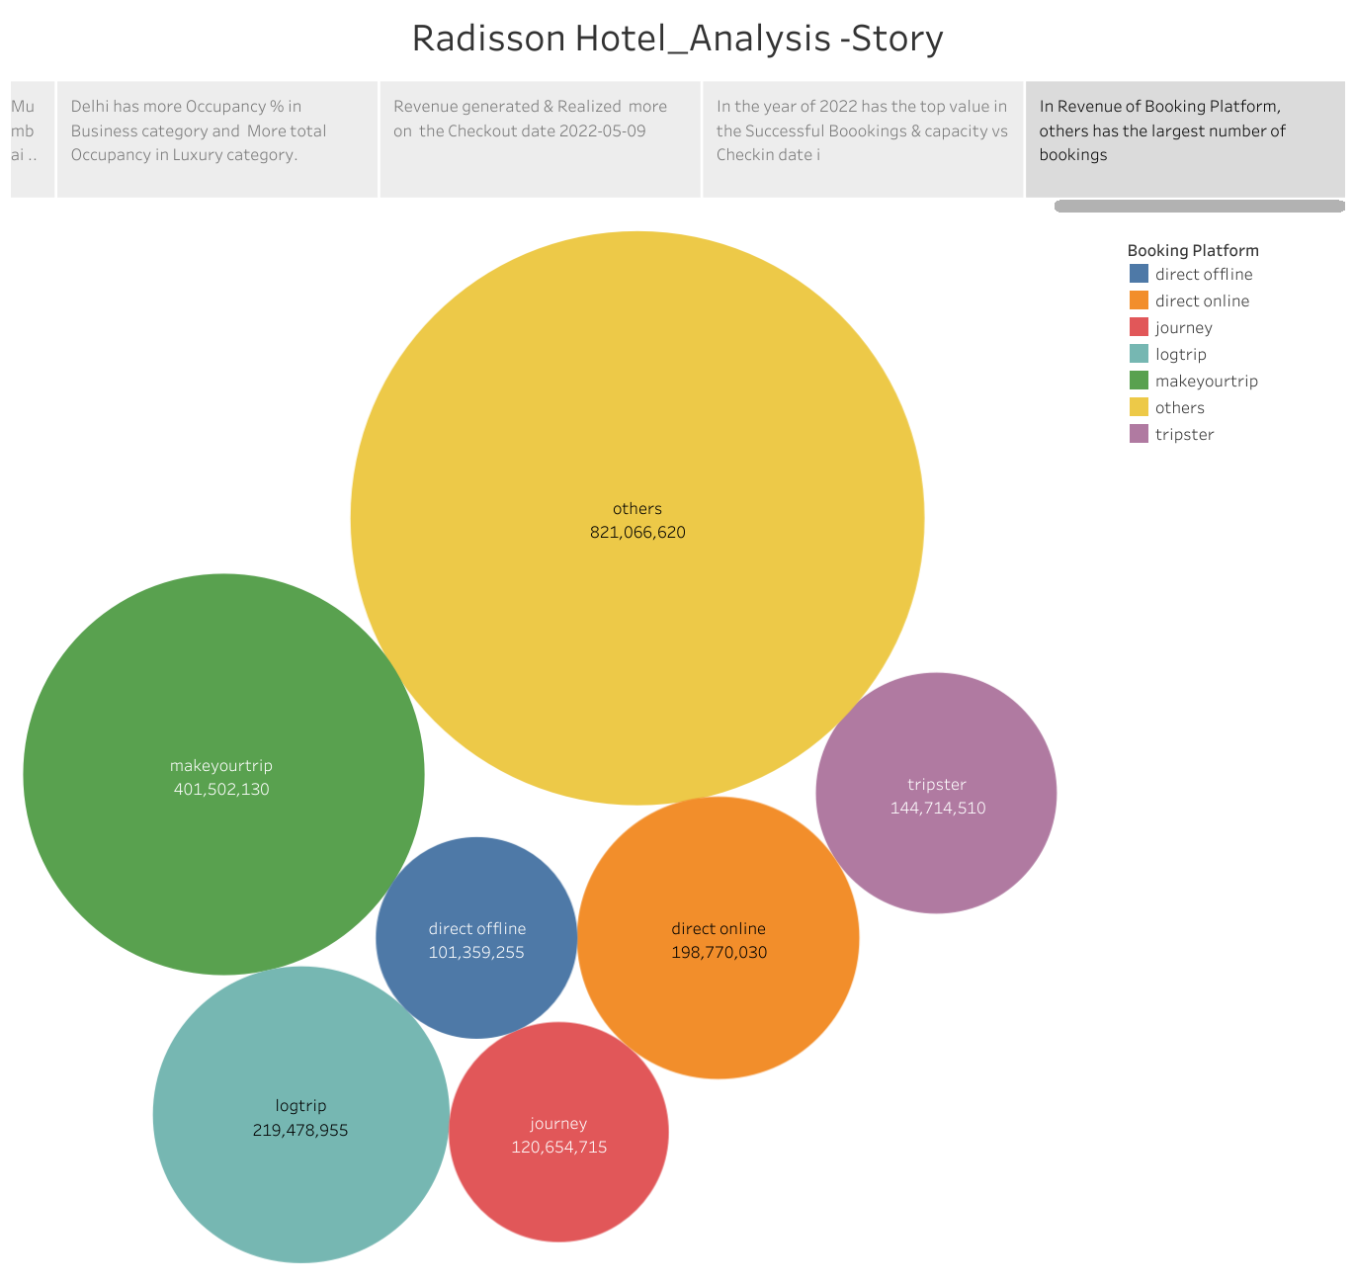

**4. ADVANTAGES & DISADVANTAGES**

**Advantages:**

* Mumbai ranks first in revenue of Radisson Hotels in cities with day type .
* Delhi has more occupancy 96 in Business category and more total occupancy in luxury category
* Radisson Exotica has received highest revenue from Mumbai .
* Radisson Blu has made the highest total occupancy
* Weekend has the highest average occupancy.
* Elite and premium room classes are the top do revenue contributors.
* Other platforms and make your trip contributors the top two level in total checked out bookings .
* Luxury hotels category has the highest revenue.
* Mumbai has made highest number if successful bookings 43,453.

**Disadvantages:**

* Revenue generated and realized more on the checkout date 2022/05/09.
* In the year of 2022 has the top value in the successful bookings and capacity vs check in date.
* In revenue of bookings platform, others has the largest number of bookings.
* Cancelled bookings percentage of Revenue for occupancy 96 of the hotels .

# APPLICATIONS

# Business Development

# Market Research

1. **CONCLUSION**

Utmost care and back-up procedures must be established to ensure 100% successful implementation of the computerized hotel system .

# FUTURE SCOPE

# Now a days hotels is providing many other facilities , this project can also be improved with the improvement in the Hotels.

# APPENDIX

A. Source Code

index.html